

CDS 3543
Data Visualization for Decision Making

Deliverable 3: Data-Driven Analysis of Student Behaviors and Their Impact on Academic Performance

Submitted By:
Mariam Almessabi | H00492656
Asma Alkarbi | H00492811
Hamdah Alkindi | H00492795

Submitted To:
Dr. Mohd Salihan Ab Rahman

Table of Contents
1. Executive Summary 3
2. Project Context 3
2.1. Problem Statement 3
2.2. Project Goals 3
2.3. Stakeholders 4
3. ETL Summary 4
3.1. Data Extraction 4
3.2. Data Transformation 4
3.3. Data Loading 5
4. Data Manipulation 6
4.1. Filtering 6
4.2. Grouping 6
4.3. Reshaping 7
5. Statistical Analysis 7
5.1. Correlation Matrix 7
6. Assumptions Testing 8
6.1. Females study more than males 8
6.2. Age affects marks 9
6.3. Internet quality affects marks 10
7. Visualization Types 11
7.1. Comparison 11
7.2. Distribution 13
7.3. Relationship 14
7.4. Composition 15
7.5. Extra Findings 16
7.6. Summary of Findings 18
8. Recommendations 18
9. Limitations 19
10. Project Conclusion 19
11. Technical Appendix 20

Table of Figures
Figure 1: Heatmap of Mental Health 7
Figure 2: Bar chart showing difference in average study hours between males and females 8
Figure 3: Pie chart showing average scores of different age groups 9
Figure 4: Bar chart showing difference in average score per internet quality 11
Figure 5: Bar chart comparing scores of employes versus unemployed students 12
Figure 6: Histogram showing exam score distribution with mean 14
Figure 7: Scatter plot showing relationship between study hours and exam score 14
Figure 8: Pie chart showing distribution of students per diet quality 16
Figure 9: Bar chart showing average social media hours per internet quality 17

Executive Summary
The project analyze how student lifestyle habits affect academic exam performance using a dataset from Kaggle that contains 1,000 student records. The dataset includes 16 features covering digital habits, sleep, diet, mental health, attendance, and study hours, with exam score as the target variable. Thorough data cleaning and preprocessing the final dataset contained 958 records ready for analysis.
Then the ETL pipeline was applied, followed by data manipulation techniques including filtering, grouping, and reshaping. Statistical analysis and assumption testing were conducted to validate relationships between variables. There is over six visualizations were produced using varoius python libaraies such as Matplotlib, Seaborn, and Plotly, that covers comparison, distribution, relationship, and composition chart types.
Key findings show that study hours have the strongest positive correlation with exam scores (r = 0.83), while social media and entertainment services (e.g., Netflix) usage are negatively correlated with performance. Mental health and attendance also play important roles. Based on these findings, this report recommends that institutions promote structured study habits, limit digital distractions, and invest in student mental health services to improve academic outcomes.

Project Context

Problem Statement
The study aims to analyze how student lifestyle choices and habits influence academic performance. Our goal is to use student behavioral data into clear visualization that support decision making in educational institutions.

Project Goals
We will analyze the relationship between student lifestyle habits (e.g., study hours, social media usage) and academic exam performance. Specifically, the project aim to produce high-quality visualizations that uncover meaningful patterns. The findings are intended to provide stakeholders with data-driven insights to design targeted involvement that improve student academic outcomes.

Stakeholders
The primary stakeholders are school administrators, who need high-level summaries to guide institutional policies, and academic advisors, who use performance metrics to identify at-risk students for early intervention. Secondary stakeholders include teachers and education analysts who examine behavioral trends for research purposes. The dashboard is not intended for individual student self-tracking or personal performance monitoring.

ETL Summary

Data Extraction
The dataset was obtained from Kaggle and loaded using pandas
df = pd.read_csv('student_habits_performance.csv')
df.head()

Data Transformation
Dropped student_id as it is an identifier serving no purpose for the study
# drop student_id column
df = df.drop(columns=['student_id'])

handled outliers
# detect outliers in exam_score using IQR method
Q1 = df['exam_score'].quantile(0.25)
Q3 = df['exam_score'].quantile(0.75)
IQR = Q3 - Q1
lower_bound = Q1 - 1.5 * IQR
upper_bound = Q3 + 1.5 * IQR
outliers = df[(df['exam_score'] < lower_bound) | (df['exam_score'] > upper_bound)]
print(f"Number of outliers in exam_score: {outliers.shape[0]}")

Number of outliers in exam_score: 2

# drop outliers
df = df[(df['exam_score'] >= lower_bound) & (df['exam_score'] <= upper_bound)]
print(f"Dataset shape after dropping outliers: {df.shape}")

Dataset shape after dropping outliers: (956, 21)

Renamed columns
# rename columns
df = df.rename(columns={'study_hours_per_day': 'study_hours', 'extracurricular_participation': 'extra_acts', 'parental_education_level': 'parent_education', 'attendance_percentage': 'attendance', 'mental_health_score': 'mental_health'})
df.columns

Encoded categorical variables
# encode gender, part_time_job, diet_quality, parent_education, internet_quality, extra_acts
df['gender'] = df['gender'].map({'Male': 0, 'Female': 1})
df['part_time_job'] = df['part_time_job'].map({'No': 0, 'Yes': 1})
df['diet_quality'] = df['diet_quality'].map({'Poor': 0, 'Fair': 1, 'Good': 2})
education_mapping = {'High School': 0, 'Bachelor': 1, 'Master': 2}
df['parent_education'] = df['parent_education'].map(education_mapping)
df['internet_quality'] = df['internet_quality'].map({'Poor': 0, 'Average': 1, 'Good': 2})
df['extra_acts'] = df['extra_acts'].map({'No': 0, 'Yes': 1})
df.head()

Imputed null values
# impute null values in parental_education with the most frequent value
most_frequent_value = df['parent_education'].mode()[0]
df['parent_education'] = df['parent_education'].fillna(most_frequent_value)

dropped null values
# drop null values in gender
df = df[df['gender'].notnull()]

dropped unnecessary columns
# drop columns social_media_hours_bin, score_range, attendance_group, study_hours_rounded, social_bin, attendance_bin
df = df.drop(columns=['social_media_hours_bin', 'score_range', 'attendance_group', 'study_hours_rounded', 'social_bin', 'attendance_bin'])
df.info()

Data Loading
After transformation, this is what our data looks like now
<class 'pandas.DataFrame'>
Index: 956 entries, 0 to 999
Data columns (total 15 columns):
# Column Non-Null Count Dtype
--- ------ -------------- -----
0 age 956 non-null int64
1 gender 956 non-null float64
2 study_hours 956 non-null float64
3 social_media_hours 956 non-null float64
4 netflix_hours 956 non-null float64
5 part_time_job 956 non-null int64
6 attendance 956 non-null float64
7 sleep_hours 956 non-null float64
8 diet_quality 956 non-null int64
9 exercise_frequency 956 non-null int64
10 parent_education 956 non-null float64
11 internet_quality 956 non-null int64
12 mental_health_rating 956 non-null int64
13 extra_acts 956 non-null int64
14 exam_score 956 non-null float64
dtypes: float64(8), int64(7)
memory usage: 119.5 KB

Data Manipulation

Filtering
# filter to find students with high grades
high_performers = df[df['exam_score'] > 80]

Grouping
# find average exam score per study hour
exam_avg = df.groupby('study_hours')['exam_score'].mean()
study_hours
0.0 40.807692
0.1 53.400000
0.2 31.500000
0.3 32.625000
0.5 39.525000
...
7.4 99.233333
7.5 100.000000
7.6 100.000000
8.2 100.000000
8.3 100.000000
Name: exam_score, Length: 78, dtype: float64

Reshaping
# rehsape to bin social media hours to categories
df['social_media_hours_bin'] = pd.cut(df['social_media_hours'], bins=[-1,2,4,6,np.inf])
df['social_media_hours_bin']

Statistical Analysis

Correlation Matrix
# statistical analysis
cols = ['study_hours', 'social_media_hours', 'netflix_hours', 'mental_health_rating', 'attendance', 'exam_score']
d3heatmap = sns.heatmap(df[cols].corr(), annot=True, cmap='coolwarm')
d3heatmap
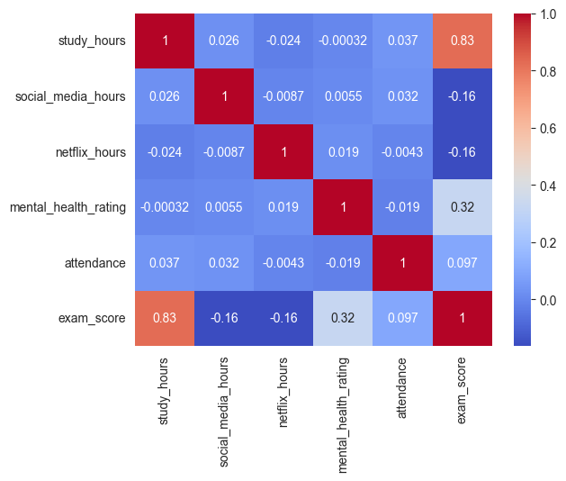
Figure 1: Heatmap of Mental Health

Assumptions Testing

Females study more than males
# assumption 1: females study more than males

# Convert 0/1 to labels
df['gender_label'] = df['gender'].map({0: 'Male', 1: 'Female'})

# Group by labels
df_grouped = df.groupby('gender_label')['study_hours'].mean().reset_index()

# Plot
fig = px.bar(
df_grouped,
x='gender_label',
y='study_hours',
color='gender_label',
title='Average Study Hours by Gender',
color_discrete_map={
'Male': 'lightblue',
'Female': 'pink'
}
)

fig.show()
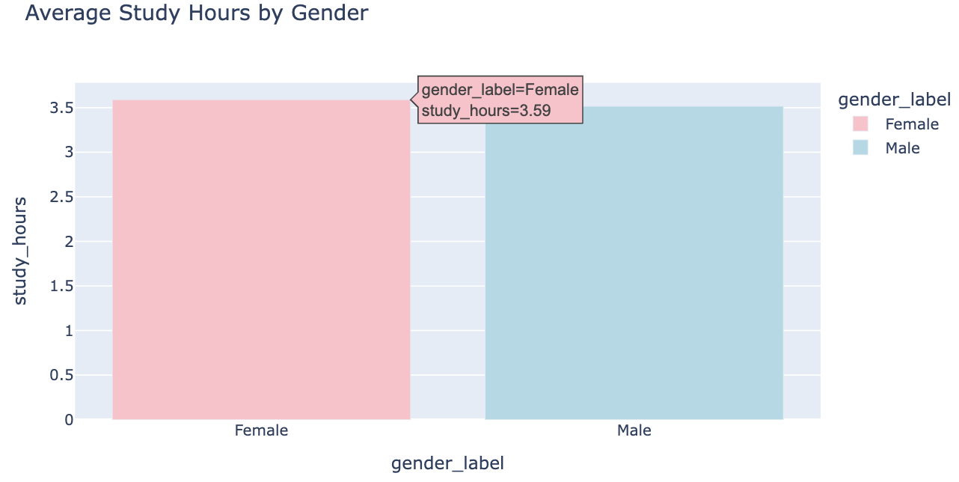
Figure 2: Bar chart showing difference in average study hours between males and females
Female average study hours = 3.59
Male average study hours = 3.51
According to the bar graph, female students spend slightly more time studying than male students with averages of 3.59 hours per day for females and 3.51 hours per day for males. It is confirmed that the assumption about the higher study time of females than males is valid.
Yet, the variations are negligible because the difference between both groups is only 0.08 hours. It may be inferred that the two groups are almost similar in terms of study times, and any significant variations do not exist.
Therefore, a hypothesis test can be conducted to find out whether the differences are significant.

Age affects marks
# assumption 2: younger students have a higher average exam score than older students
# Create age bins
df['age_group'] = pd.cut(df['age'], bins=[0, 18, 22, 30], labels=['<18', '18-22', '22+'])
# Group by age group
age_avg = df.groupby('age_group')['exam_score'].mean().reset_index()
# Plot pie chart
fig = px.pie(
age_avg,
names='age_group',
values='exam_score',
title='Average Exam Score by Age Group',
color_discrete_sequence=px.colors.sequential.RdBu
)
fig.show()
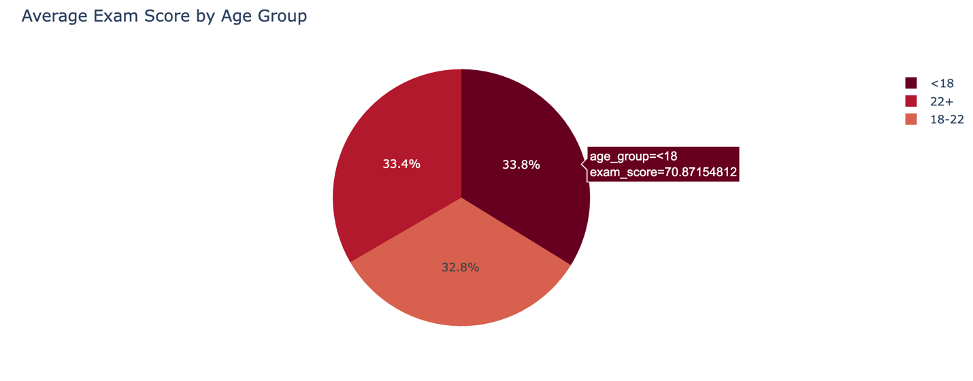

Figure 3: Pie chart showing average scores of different age groups
Less than 18 avg score = 70.87
18 to 22 avg score = 68.86
22+ avg score = 70.03
The findings reveal that the highest average marks in the exam are attained by the students less than 18 years old (70.87), followed by students between 22+ years old (70.03), while students between 18 and 22 years old have the lowest average marks (68.86).
This shows that freshmen students have a more serious attitude towards grades, especially since their courses are also easy first year courses. Next, comes sophomores and juniors with some senior students whose marks are affected as course work progressively gets more difficult. Finally, most senior students work towards repeating courses or working harder on their final year to improve their overall GPA.
Decision makers should focus their resources more on sophomores and juniors to ensure they get a feasible and balanced workload to achieve higher marks.

Internet quality affects marks
# assumption 3: higher internet quality is associated with higher exam scores
# group data
internet_avg = df.groupby('internet_quality')['exam_score'].mean().reset_index()

# map numbers to labels
internet_labels = {0: 'Poor', 1: 'Average', 2: 'Good'}
internet_avg['internet_quality_label'] = internet_avg['internet_quality'].map(internet_labels)

# plot
fig = px.bar(
internet_avg,
x='internet_quality_label',
y='exam_score',
title='Average Exam Score by Internet Quality',
color='internet_quality_label',
color_discrete_map={
'Poor': '#EF553B',
'Average': '#FECB52',
'Good': '#00CC96'
}
)

fig.show()
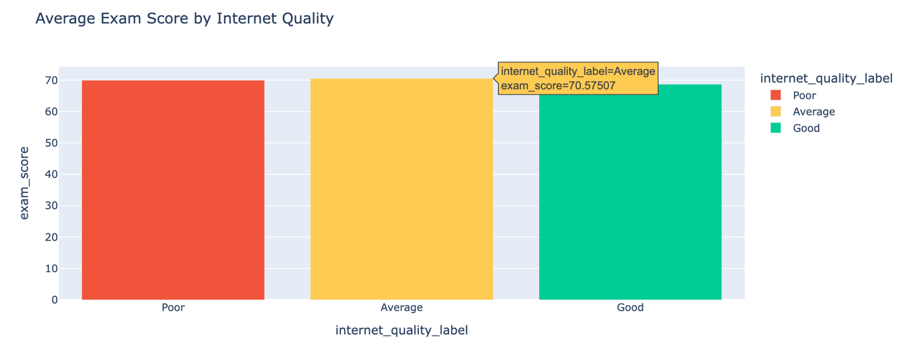
Figure 4: Bar chart showing difference in average score per internet quality
Poor internet avg marks = 69.98
Average internet avg marks = 70.57
Good internet avg marks = 68.72
It can be seen from the analysis results that the highest exam score is achieved for students having average internet quality (70.57). Then follows the group of students having poor internet quality (69.98). The lowest result is achieved by students having good internet quality (68.72).
The obtained results do not match the assumption that high internet quality results in high scores. The opposite situation occurs.
Also, there are slight distinctions between the groups, which implies that internet quality has no substantial impact on exam results. Rather, high performance from this chart appears to be more ambitious driven where students who want to study will find a way, regardless of internet quality. Therefore, the initial assumption cannot be used since it is proven to be wrong, according to the chart. A more advanced statistical testing could be employed to uncover a more accurate result.

Visualization Types

Comparison
Tested to see whether students with part time jobs have lower marks than those without

# average exam score by part time job
avg_scores = df.groupby('part_time_job')['exam_score'].mean().reset_index()

# map labels
avg_scores['part_time_job'] = avg_scores['part_time_job'].map({
0: 'No',
1: 'Yes'
})

# bar chart
fig = px.bar(
avg_scores,
x='part_time_job',
y='exam_score',
color='part_time_job',
title='Average Exam Score by Part Time Job',
labels={
'part_time_job': 'Part Time Job',
'exam_score': 'Average Exam Score'
},
color_discrete_map={
#color-blind accessibility
'No': '#D55E00',
'Yes': '#009E73'
}
)

fig.show()
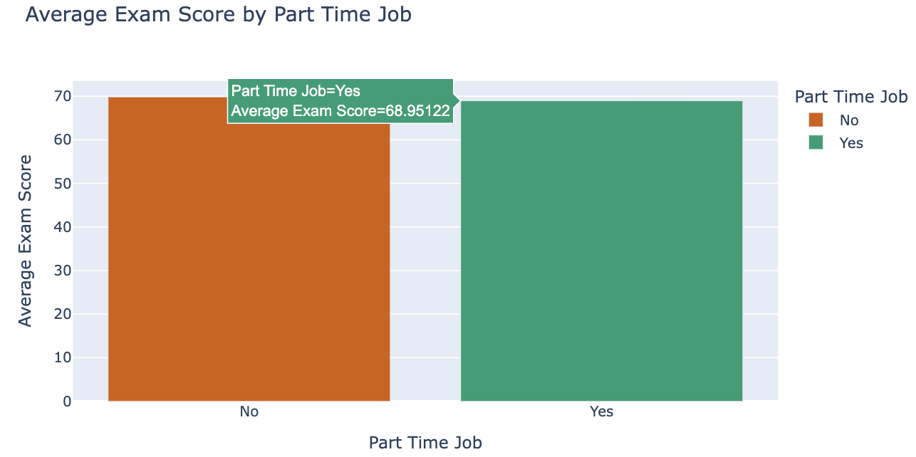
Figure 5: Bar chart comparing scores of employes versus unemployed students

Not employed average score = 69.85
Employed average score = 68.95
For comparison, we used a bar chart to determine the differences in the mean exam score between students who have and those who do not have part-time employment. The bar chart displays the differences between the two categories.
Based on the results, the average test score for unemployed students (69.85) was slightly higher than employed students (68.95). This might be because employed students must make time for both work and studies, and this reduces the available time for studying.
The difference (0.9 points) between the two categories is minimal, meaning that part-time employment does not significantly affect academic success.
Decision making-wise, educational establishments can accommodate working students through flexible scheduling and academic counseling among others.

Distribution
The use of distributions charts was employed to determine the dispersion of test scores in the data set. A histogram has been utilized to present the distribution of test scores and found that most of the students scored within the range of 60 to 80. It means that the average performance of the students is good and only few perform poorly. Theres also a noticeable number of students who got full marks, showing the diverse range of performances among students.

# exam score distribution
plt.figure(figsize=(9, 5))
sns.histplot(df['exam_score'], bins=20, kde=True,
edgecolor='black')
plt.axvline(df['exam_score'].mean(),
color='red', linestyle='--', linewidth=1.5,
label=f"Mean: {df['exam_score'].mean():.2f}")
plt.title('Distribution of Exam Scores')
plt.xlabel('Exam Score')
plt.ylabel('Frequency')
plt.legend()
plt.tight_layout()
plt.show()

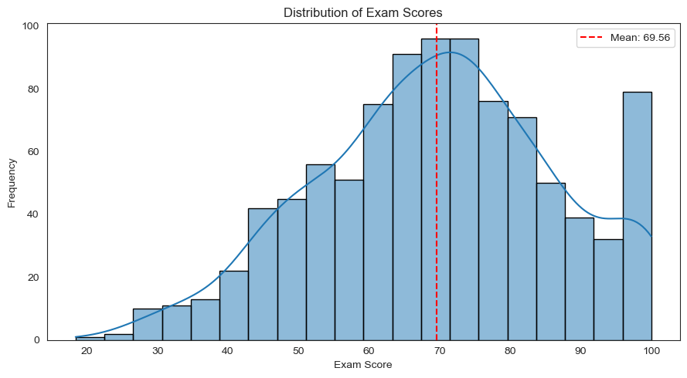
Figure 6: Histogram showing exam score distribution with mean

Relationship
import plotly.express as px

fig = px.scatter(df,
x='study_hours',
y='exam_score',
title='Study Hours vs Exam Score',
trendline='ols')

fig.show()
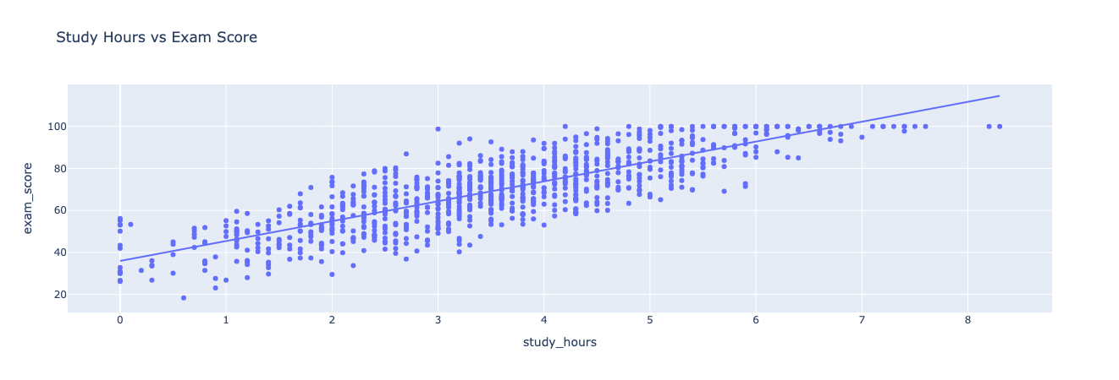
Figure 7: Scatter plot showing relationship between study hours and exam score
For visualizing, we used a scatter plot to show the correlation between study hours and exam scores.
By looking at the plot, we can see a strong positive correlation between the number of study hours and exam scores. Students who have spent more time studying have achieved better scores than others. The trendline indicates a similar pattern without any outlier points. It was found that students with longer study hours had obtained higher marks.
Scatter plots were used because it is one of the methods that demonstrate the relationship between two variables using data points.
From a decision maker’s perspective, it means that promoting a positive attitude towards more studying hours will result in high academic performance.

Composition
# composition of students by diet quality
# map numbers to labels
diet_labels = {0: 'Poor', 1: 'Fair', 2: 'Good'}
df['diet_quality_label'] = df['diet_quality'].map(diet_labels)

# count students in each category
diet_counts = df['diet_quality_label'].value_counts().reset_index()

# rename columns
diet_counts.columns = ['diet', 'count']

# plot pie chart
fig = px.pie(
diet_counts,
names='diet',
values='count',
title='Distribution of Students by Diet Quality',
color='diet',
color_discrete_map={
'Poor': '#EF553B',
'Fair': '#FECB52',
'Good': '#00CC96'
}
)

fig.show()
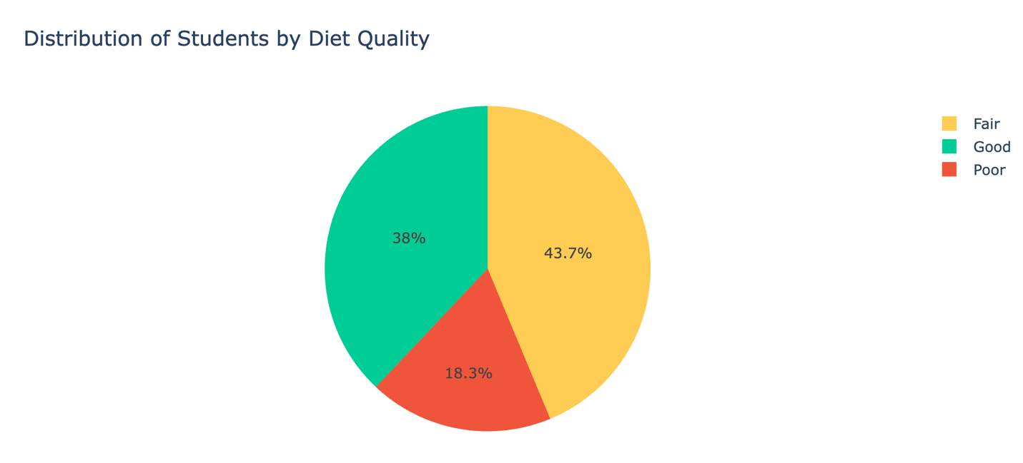

Figure 8: Pie chart showing distribution of students per diet quality

From the composition graph above, it is evident that most of the students have a fair diet, 43.7% to be exact. The second highest number of students is that of those having good diet quality, which amounts to 38%. It should be noted that only 18.3% of the total students have poor diet quality.
This implies that most of the students are healthy eaters. As far as decision making goes, it will be very useful for stakeholders since it helps understand the overall lifestyle composition of students from the given data.

Extra Findings

Tested to see whether students with higher internet spend more time on social media
# do people with good internet spend more time on social media?
internet_social = df.groupby('internet_quality')['social_media_hours'].mean().reset_index()
internet_social['internet_quality_label'] = internet_social['internet_quality'].map(internet_labels)
fig = px.bar(
internet_social,
x='internet_quality_label',
y='social_media_hours',
title='Average Social Media Hours by Internet Quality',
color='internet_quality_label',
color_discrete_map={
'Poor': '#EF553B',
'Average': '#FECB52',
'Good': '#00CC96'
}
)
fig.show()
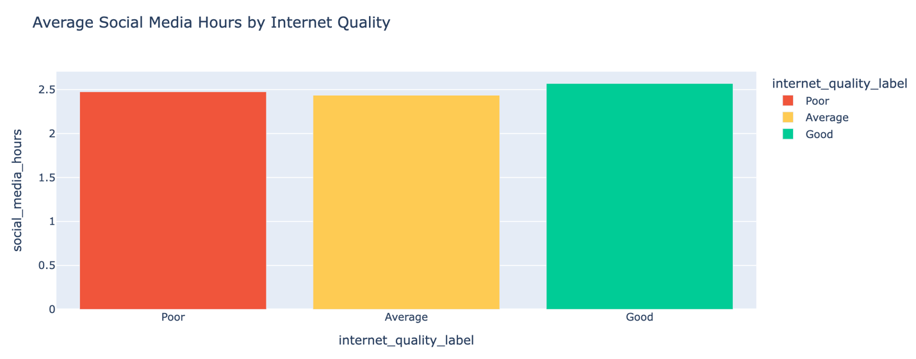
Figure 9: Bar chart showing average social media hours per internet quality
Poor internet avg social media hours = 2.47
Average internet avg social media hours = 2.43
Good internet avg social media hours = 2.56
The findings indicate that those with quality internet use more hours on social media (2.56 hours) than poor quality (2.47 hours) and average quality (2.43 hours) have the least hours spent.
There’s no clear distinct relationship between internet quality and social media hour. However, the assumption was proven to be correct.
Those who have quality internet probably have easy access to it, and so, the use is high.
However, the variance within the three samples is so minimal (just about 0.1 hour each), and therefore, there is no practically significant effect.
So, the correlation between the two variables is slightly supported but does not carry much weight. The university should promote healthier digital habits so privileged students can take advantage of this opportunity and the university should also ensure all students on campus have the necessary level of internet quality for learning.

Summary of Findings
Study hours proved to be the highest positively correlated feature with exam performance (r = 0.83), which means that the more time students’ study, the better exam results they could get.
Female students spend more time for studying compared to male students and spend on average 3.59 study hours.
As for student age, students aged under 18 were found to be top performers with average exam scores of 70.87, whereas students aged between 18 and 22 got lower grades.
As for internet quality, its impact on academic success was not strong since students with average internet quality achieved the highest average exam scores, while those with good internet quality used more time for social media, hence their slightly lower exam scores.
Most students scored in the range from 60s to 80s, achieving an average score of 69.56 for exam scores. Also, a good number of students ate on a fairly rated diet. However, there were also a small number of students whose diets were poor. Part-time job had little effect on academic performance.

Recommendations
Promote good study habits: There is a strong correlation between the academic performance of students and their study habits (r = 0.83). It means that those students who put a lot of effort into their studying will receive better scores. The university are expected to promote effective habits, as well as provide the help through academic and time management support programs.
Limit the use of social media: The academic performance is negatively affected by the level of social media use by students. It distracts them and limits the amount of time students can spend on studying. Therefore, institutions need to educate them about the effects of this activity.
Provide psychological support: Students who receive lower scores tend to feel dreadful. Therefore, educational institution needs to pay much attention to the student mental health and develop supportive programs for their students.
Support students between 18–22: The data showed that students aged 18-22 years performed somewhat lower than older students. So, the university should focus on helping them to enhance their performance level, by adjusting their workload and creating balanced schedules.
Focus on behavioral factors: To encourage more effective studying on campus, the university can implement peer-tutoring initiatives and provide quiet zones for studying that will help students to have more productive time studying. Also, implementing a ‘no phones' policy during class and in certain areas, and educating students about the negative effects of excessive social media use would be helpful.
Consider the effects of lifestyle: The university needs to encourage students to live healthy lives through promoting frequent exercising and opening a gym on campus, nutritious eating by opening healthy cafes and restaurants, and healthy sleeping habits by concentrating most classes during the daytime. Also conduct mental health programs aimed at improving students’ wellbeing.

Limitations
In this project, some limitations were found. First, the sample size used for the analysis is close to 1000 students only, meaning that it does not represent the entire population of all students. Second, the relationship between the variables is determined by correlations, which implies the lack of causation and explainability. There might be other factors that can affect the performance of students in exams not present in the data.
In addition, there are some variables that can impact the academic performance of students, which were not included in the dataset. Finally, certain data preprocessing measures can introduce a bias in the analysis.

Project Conclusion
In conclusion, this project completed an analysis of students' behavior and habits and their influences on academic performance using data visualization and statistical analysis. We followed the entire process of data analysis, which consists of ETL, cleansing, preprocessing, manipulation, assumptions, testing, and visualization. We’ve gained valuable insights on how different factors play a role in impacting exam scores.
We discovered that study hours are the most positively correlated with exam scores. Besides, excessive usage of social media and Netflix negatively impacts the performance of students. Additionally, the mental health and attendance have a considerable impact on exam scores. However, internet connectivity and part-time jobs play less important roles.
Using visualizations and dashboards, this data will be useful for the main stakeholders, including university administration, academic advisers, professors, analysts, and educational researchers to take the necessary measures based on data analysis to improve wellbeing and encourage positive habits, which in turn improves academic performance of students.
Data Visualization is a powerful technique that allows discovering hidden patterns and making decisions-based data obtained to increase students' performance. In the future, we will expand the data by aggregating different related datasets and analyzing more variables and using more advanced methods of analysis.

Technical Appendix
Libraries Used
pandas, numpy, matplotlib, seaborn, plotly (with plotly.express and statsmodels for trendlines).

Install Libraries
pip install pandas numpy matplotlib seaborn plotly

Dataset Description
The raw dataset contains 1,000 student records and 16 features related to academic performance and lifestyle.
Key variables include:
- Academic behavior: study hours per day, attendance percentage
- Digital behavior: social media hours, Netflix hours
- Health and lifestyle: sleep hours, diet quality, exercise frequency
- Demographic factors: age, gender, parental education level, internet quality, employment
- Psychological factor: mental health rating
- Target variable: exam score
After preprocessing, the final shape was (956, 15)

Data Preprocessing Summary
Data cleaning and preparation for accuracy were conducted. Important data preparation activities carried out include:
- Dropped unnecessary columns like student_id and temporarily created bins for earlier visualizations
- Handled outliers in exam scores using IQR
- Renamed columns for simplicity
- Encoded the categorical variables
- Imputed null values in parent education with the mode
- Dropped null values in gender
Outcome: 956 cleaned records for analysis.

Reproducibility Instructions
This project is fully reproducible and the notebook with the datasets and necessary associations are found in the following link:
https://github.com/mariamalm/CDS-3543-Group2/tree/main
- Ensure all the libraries mentioned above are installed
- Clone or download the project’s repo from GitHub
- Open the Jupyter notebook file “main_d3.ipynb”
- Ensure the dataset “student_habits_performance.csv” is in the same workspace as the notebook
- Run the notebook cells in their exact sequence to execute preprocessing and visualization

THE END.

